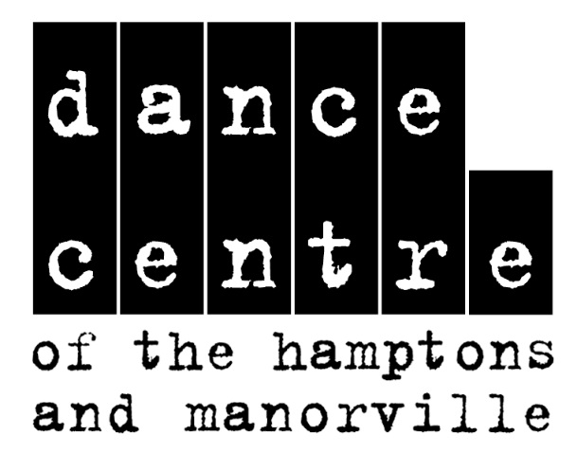

Special Offer This Year
FREE COSTUME
For All Twinkle Toe and Creative Movement Classes
Check out our schedule on our website
www.dancecentreofthehamptons.com
or call to schedule your free trial class.

We have two convenient locations.

Westhampton Beach Manorville
10 Mitchell Road 460 County Road 111
(631) 288-8594 (631) 395-8594

